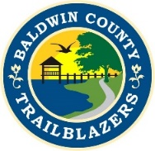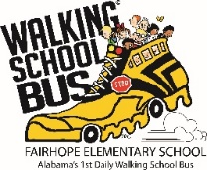
Walking School Bus
2019 Sponsor Commitment

To confirm sponsorship of the WSB, please complete the following:

Date__________________
Name (organization/individual)_______________________________
List exactly how you want the sponsor name listed:_______________
__________________________________________________________
Address___________________________________________________
__________________________________________________________
Phone number_____________________________________________
Email_____________________________________________________

Logo: if your level of sponsorship includes the use of your company logo, please supply the logo in a high-resolution format to: walkingschoolbusfes@gmail.com.

Please confirm your level of sponsorship:

Presenting $5000________
Title $2500_____________
Gold $1000_____________
Silver $500_____________
Bronze $250____________
Friend $100____________
Other _________________

Checks should be written to Baldwin County Trailblazers (for WSB)
Baldwin County Trailblazers
PO BOX 701
Daphne, Alabama 36526

All communications about sponsorship should be directed to Charlene Lee, Walking School Bus Director. Contact information: 251-402-2795 or charlenelee366@gmail.com.

